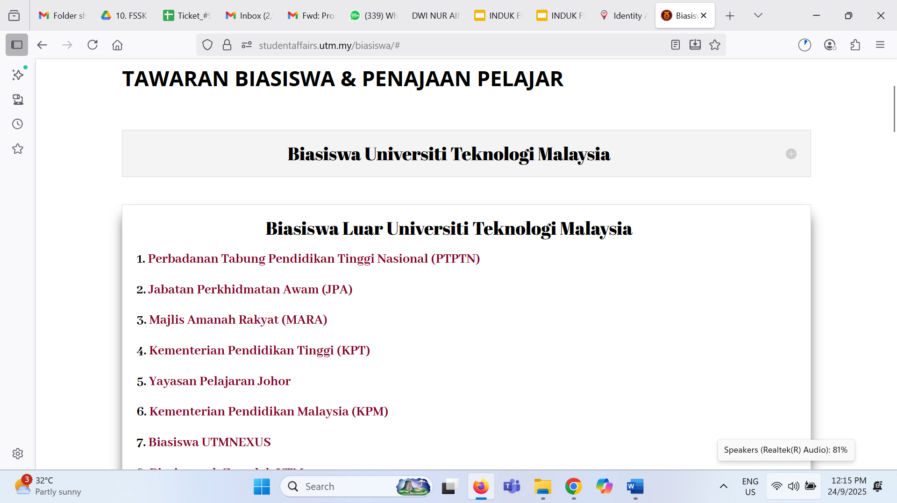**https://studentaffairs.utm.my/biasiswa/#**